**Software Requirements Specification**

For

Wookies: Mentor Allocation System

27thOct,2023

Prepared by

|  |  |  |
| --- | --- | --- |
| **Specialization** | **SAP ID** | **Name** |
| CCVT | 500094565 | Aashika Gupta |
| CCVT | 500094922 | Hardik Singh |
| CCVT | 500095581 | Om Gupta |

Guided By: Dr Keshav Sinha (Assistant Professor)



Department of Systemics

School Of Computer Science

UNIVERSITY OF PETROLEUM & ENERGY STUDIES,

DEHRADUN- 248007. Uttarakhand

Table of Contents

|  |  |  |
| --- | --- | --- |
| **Topic** | | **Page No** |
| Table of Content | | 2 |
| Revision History | | 2 |
| 1 | Introduction | 3 |
|  | 1.1 Purpose of the Project | 3 |
|  | 1.2 Target Beneficiary | 3-4 |
|  | 1.3 Project Scope | 4 |
|  | 1.4 References | 4 |
| 2 | Project Description | 5 |
|  | 2.1 Data/ Data structure | 5 |
|  | 2.2 SWOT Analysis | 5-6 |
|  | 2.3 Project Features | 6-7 |
|  | 2.4 Design and Implementation Constraints | 7-8 |
|  | 2.5 Design diagrams | 8-10 |
| 3 | System Requirements | 10 |
|  | 3.1 User Interface | 10-11 |
|  | 3.2 Protocols | 12 |
| 4 | Non-functional Requirements | 12 |
|  | 4.1 Performance requirements | 12-13 |
|  | 4.2 Security requirements | 13 |
| Appendix A: Glossary | | 14 |

**Revision History**

|  |  |  |  |
| --- | --- | --- | --- |
| **Date** | **Change** | **Reason for Changes** | **Mentor Signature** |
|  |  |  |  |
|  |  |  |  |
|  |  |  |  |
|  |  |  |  |

1. INTRODUCTION

This project- the "Mentor Allocation System" allows mentors to the students based on their choice filling. Firstly, the professors need to register themselves. They are verified, and the professors need to upload their area of interest when every profession is done with it, the admin updates, and the number of students to be allotted under a particular Professor. Now the student asked to register on the website. The students need to fill out the Choice filling with which professor they want to work. After each student is done with it, the admin generates the list containing students along with their allotted Mentors. Both the students and professor get the confirmation with whom they have to work. And the whole process is complete.

1.1 Purpose of the Project

The purpose of the Mentor & Sponsor Allocation System Project is to streamline, enhance, and optimize the process of connecting mentors with mentees and proteges within an organization or educational institution. This project serves several important purposes:

Efficient Matching: The project aims to efficiently match mentors with mentees and sponsors with proteges based on compatibility, goals, skills, and expertise. This ensures that mentorship and sponsorship relationships are more likely to be productive and beneficial for all parties involved.

Time and Resource Optimization: The system automates administrative tasks related to mentorship and sponsorship, such as matching, scheduling, and communication, saving valuable time and resources for mentors, sponsors, and program administrators. This allows participants to focus on the core aspects of the mentoring and sponsorship relationships.

Professional Growth and Success: Ultimately, the primary purpose of the Mentor & Sponsor Allocation System Project is to contribute to the professional growth and success of individuals within the organization. By facilitating valuable mentorship and sponsorship relationships, the project empowers individuals to reach their full potential.

1.2 Target Beneficiary

The Mentor & Sponsor Allocation System Project targets several key beneficiaries within organizations, educational institutions, and other entities that implement mentorship and sponsorship programs. These beneficiaries include

Mentees: Mentees are individuals who seek guidance, support, and mentorship to advance their personal and professional goals. They benefit from the project by gaining access to experienced mentors and sponsors who can provide valuable insights, advice, and growth opportunities.

Mentors: Mentors are typically seasoned professionals or experts in their respective fields who are willing to share their knowledge, expertise, and networks with mentees and proteges. The project benefits mentors and sponsors by facilitating meaningful mentorship and sponsorship relationships, allowing them to give back to their communities and organizations.

Organizations and Institutions: The project benefits the organizations and institutions that implement mentorship and sponsorship programs by enhancing the professional development and engagement of their members or employees. This, in turn, can lead to increased retention rates, improved skills development, and a more positive organizational culture.

1.3 Project Scope

Develop a web-based system to efficiently match mentors with mentees and sponsors with proteges within an organization or educational institution. Facilitate communication, resource sharing, and progress tracking between mentors/sponsors and their respective mentees/proteges. Provide administrative tools for program managers to oversee and enhance mentorship and sponsorship programs.

1.4 References

[1] Arnesson, Kerstin, and Gunilla Albinsson. "Mentorship–a pedagogical method for integration of theory and practice in higher education." Nordic Journal of Studies in Educational Policy 3.3 (2017): 202-217.

[2] Szabo, S., Lloyd, B., McKellar, D., Myles, H., Newton, H., Schutz, J., Hahn, L. and Galletly, C., 2019. 'Having a mentor helped me with difficult times': a trainee-run mentoring project. Australasian Psychiatry, 27(3), pp.230-233.

[3] Posner, B. & Kouzes, J. (1993). Credibility. San Francisco: Jossey Bass. p. 155 [8] Google Docs..

2. PROJECT DESCRIPTION

2.1 Data/ Data Structure

Data Structures:

Database Tables: Relational database tables (e.g., SQL databases like MySQL, and PostgreSQL) will be used to store structured data, such as user profiles, program details, communication records, and feedback responses.

Queues: Message queues (e.g., RabbitMQ, Apache Kafka) will be employed for managing real-time communication, notifications, and background processing tasks.

Arrays and Lists: These data structures are used to manage collections of items, such as user lists, program participant lists, and resource collections.

Trees (e.g., Binary Search Trees): These data structures are valuable for organizing and searching data efficiently, such as searching for users or programs based on specific criteria.

Algorithms:

Matching Algorithms: Algorithms for pairing mentors with mentees and sponsors with proteges based on compatibility scores. Common matching algorithms include weighted scoring, greedy algorithms, and graph algorithms (e.g., bipartite graph matching).

Search Algorithms: Algorithms for searching and retrieving data from collections or databases, such as binary search and database query optimization.

Sorting Algorithms: Algorithms for sorting data, which may be used in various parts of the system, such as sorting user lists or program schedules.

2.2 SWOT Analysis

A SWOT analysis for the Mentor & Sponsor Allocation System Project provides an assessment of its strengths, weaknesses, opportunities, and threats. This analysis can help project stakeholders identify key factors that may influence the project's success and guide strategic decision-making. Here's a SWOT analysis for the project:

Strengths:

Personalized Development: The system allows for tailored mentor pairings based on specific criteria, ensuring that students receive personalized guidance and support.

Skill Enhancement: It facilitates skill development, knowledge transfer, and professional growth by connecting students with experienced mentors and influential sponsors.

Effective Communication: The platform facilitates seamless communication between users, fostering collaboration and knowledge exchange.

Weaknesses:

Resource Intensive: Setting up and maintaining the system can be resource-intensive in terms of time, personnel, and technology, which may not be feasible for all organizations.

Participant Commitment: Ensuring that both mentors and students stay committed to the program can be challenging, as it relies on their active engagement.

Data Privacy Concerns: Ensuring the privacy and security of user data is critical and may require ongoing vigilance and compliance efforts.

Opportunities:

Scalability: The system can be expanded to serve a broader range of organizations and institutions, increasing its impact and revenue potential.

Networking and Relationship Building: The program can create opportunities for networking and relationship building, benefiting both students and mentors in terms of career growth and personal development.

Leadership Pipeline: Developing a robust mentorship system can help identify and groom future leaders within the organization.

Threats:

Lack of Participation: If mentors and students do not actively participate, the program's effectiveness may be compromised.

Conflicts of Interest: There's a potential for conflicts of interest if mentors have personal or professional connections with their students, which could lead to favoritism.

Regulatory Changes: Changes in data protection regulations or legal requirements may necessitate system adjustments.

2.3 Project Features

The features of the Mentor & Sponsor Allocation System Project are essential components that make the system effective and user-friendly. These features cater to the needs of mentors, mentees, sponsors, proteges, and program administrators. Here's a list of key features for the project:

1. User Registration and Profiles:

User registration with role selection (mentor, mentee, sponsor, protege, administrator).

User profile creation with personal and professional details.

Profile editing and management.

2. Matching Algorithm:

Efficient matching algorithm to pair mentors with mentees and sponsors with proteges based on compatibility factors (skills, goals, preferences).

Compatibility score calculation.

3. Program Management:

Program creation and management by administrators.

Program details, objectives, and eligibility criteria.

Program schedule and duration.

4. Resource Sharing:

Capability for mentors and sponsors to share resources with mentees and proteges.

Resource library for easy access to shared articles, courses, and materials.

2.4 Design and Implementation Constraints

When designing and implementing the Mentor & Sponsor Allocation System Project, it's essential to consider various constraints and limitations that may impact the project's development and deployment. These constraints can encompass technical, budgetary, regulatory, and organizational factors.

Here are some key design and implementation constraints to keep in mind:

Budget Constraints:

Limited financial resources may restrict the scope of the project, affecting the selection of technologies, infrastructure, and development resources.

Time Constraints:

The project may have tight deadlines for development, testing, and deployment, which can impact the depth of features and thoroughness of testing.

Technical Expertise:

The availability of skilled developers and technical expertise within the project team or organization can influence technology choices and system complexity.

Data Privacy and Security Regulations:

Adherence to data protection regulations (e.g., GDPR) may impose constraints on data handling, storage, and access, necessitating robust security measures.

2.5 Design Diagram

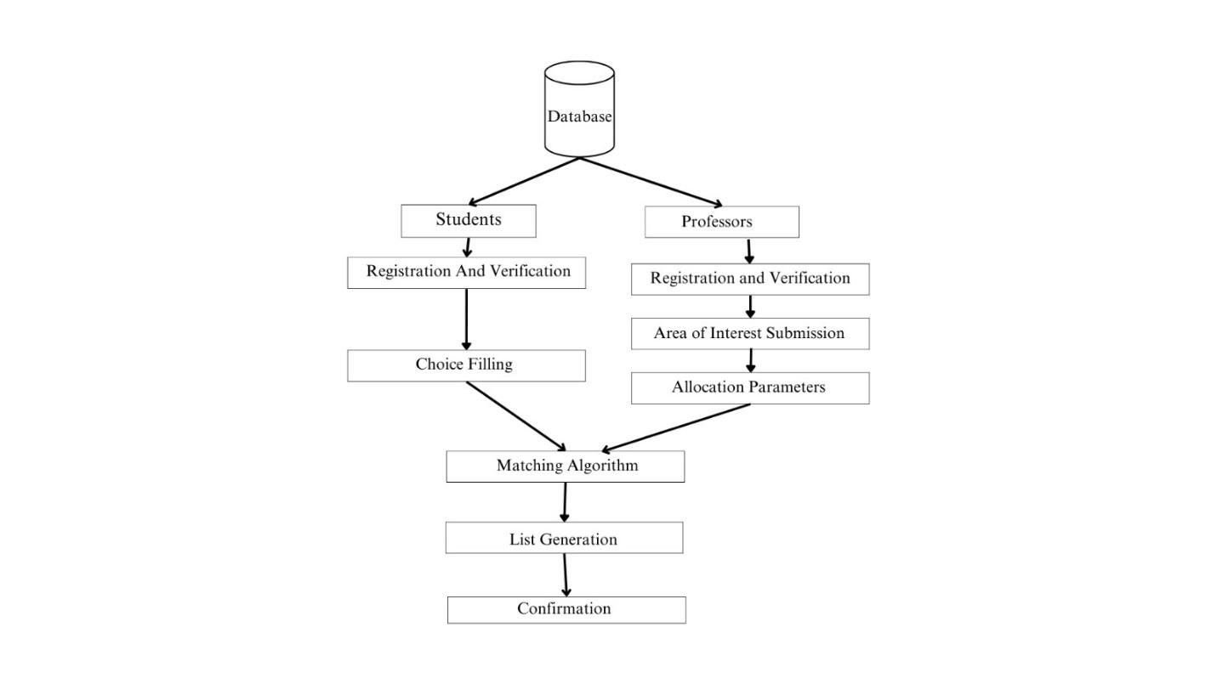

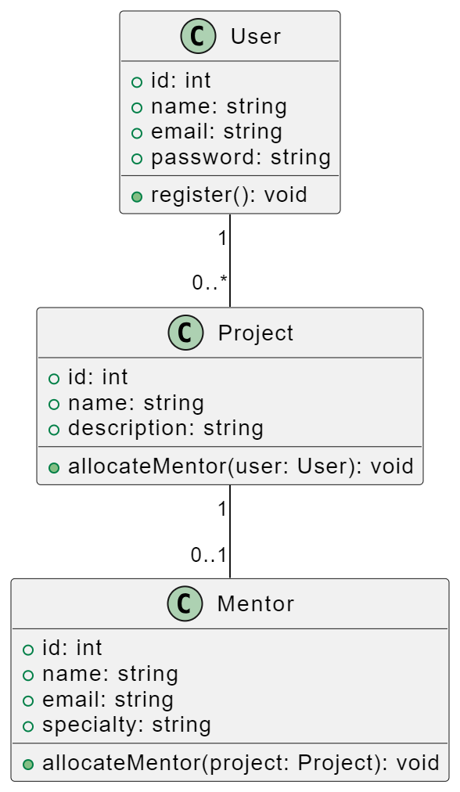

High-Level Architecture:

User Interface (UI):

The UI layer represents the web-based interface accessible to users, including mentors, mentees, sponsors, proteges, and administrators.

It includes user registration, login, profile management, program search, messaging, and resource-sharing interfaces.

Application Layer:

The application layer contains the core logic and functionality of the system.

Key components include:

User Management: Handles user registration, authentication, and profile management.

Matching Engine: Implements the matching algorithm for pairing mentors with mentees and sponsors with proteges.

Program Management: Manages mentorship and sponsorship programs, including creation, scheduling, and participant assignment.

Communication Tools: Facilitates messaging, chat, and scheduling functionalities.

Resource Management: Manages shared resources and resource libraries.

Feedback System: Collects and analyzes feedback from mentees, proteges, mentors, and sponsors.

Administrative Tools: Provides program administrators with tools for oversight, approval, and reporting.

Data Layer: The data layer stores and manages all system data, including user profiles, program details, matching data, communication records, resources, and feedback.

It typically involves a relational database management system (RDBMS) or a NoSQL database.

Integration Layer: The integration layer handles interactions with external systems or services, such as email services for notifications or third-party APIs for additional functionalities.

It ensures seamless data exchange between the system and external components.

Security Layer: The security layer encompasses measures to protect user data, including encryption, access controls, and compliance with data protection regulations.

It also includes mechanisms for user authentication and authorization.

Infrastructure Layer: The infrastructure layer consists of the server infrastructure, hosting services, and networking components required to deploy and run the system.

It includes servers, load balancers, databases, and cloud services.

Mobile Accessibility: While not a separate layer, it's essential to ensure that the system is accessible via mobile devices through responsive design or a dedicated mobile app.

3. SYSTEM REQUIREMENTS

3.1 User Interface

Designing a user interface (UI) for the Mentor & Sponsor Allocation System Project is crucial to ensure that users, including mentors, mentees, sponsors, proteges, and administrators, can easily access and utilize the system's features. Below is a conceptual description of the user interface components and their functionalities:

1. Home Page:

The home page serves as the entry point for users and provides an overview of the system.

It may include a welcome message, system announcements, and quick links to key sections.

2. User Registration and Login:

Users can create new accounts or login to existing ones.

Registration forms collect essential user information, including name, email, role, and password.

Login forms allow authenticated access to the system.

3. User Profile:

Each user has a dedicated profile page to manage their personal and professional information.

Users can edit their profiles, add profile pictures, and update contact details.

Profiles may display information such as skills, expertise, and program affiliations.

4. Program Dashboard:

The program dashboard provides an overview of the mentorship and sponsorship programs available.

Users can browse and search for programs based on criteria like program name, objectives, and eligibility.

5. Program Details:

Clicking on a program in the dashboard displays detailed information about that program, including its objectives, schedule, and mentors associated with it.

6. Matching and Recommendations:

The system provides a section for users to view their mentor/mentee matches.

Recommendations for potential matches are also displayed based on compatibility scores.

The design of the user interface should prioritize user experience (UX) and usability, ensuring that users can easily access the system's features and interact with other participants in mentorship and sponsorship programs. Additionally, user feedback and iterative design should be used to refine and enhance the UI based on user needs and preferences.

3.2 Protocols

The Mentor & Sponsor Allocation System Project will utilize various protocols to ensure secure and efficient communication between its components and with external systems. Here are some protocols commonly used in this system:

HTTP/HTTPS (Hypertext Transfer Protocol/Secure):

HTTP is used for communication between web clients (browsers) and web servers.

HTTPS is a secure version of HTTP, providing data encryption and authentication, ensuring secure data transfer.

SMTP (Simple Mail Transfer Protocol):

SMTP is used for sending email notifications and alerts to users, such as registration confirmations and password reset emails.

IMAP/POP3 (Internet Message Access Protocol/Post Office Protocol):

IMAP and POP3 are used for email retrieval by clients, allowing users to access their messages through email clients or within the system.

TCP/IP (Transmission Control Protocol/Internet Protocol):

TCP/IP is the foundation of internet communication, used for data packet transmission between devices over a network.

4. NON-FUNCTIONAL REQUIREMENTS

4.1 Performance requirements:

Performance requirements for the Mentor & Sponsor Allocation System Project are crucial to ensure that the system operates efficiently, providing a responsive and reliable experience for users. These requirements focus on factors such as response times, scalability, and resource utilization. Here are some key performance requirements for the project:

Response Time:

The system should respond to user interactions (e.g., page loads, and form submissions) within a reasonable timeframe to provide a smooth user experience.

Specific response time targets should be defined for various actions, such as loading user profiles, sending messages, and accessing program details.

Load Time:

Web pages and resources (e.g., images, scripts, stylesheets) should load quickly to minimize user wait times.

Load time requirements should specify maximum load times for different page types and resources.

Scalability:

The system should be designed to handle an increasing number of users, mentorship/sponsorship programs, and concurrent interactions.

Scalability requirements should outline how the system scales horizontally (adding more servers) or vertically (increasing server resources) to accommodate growth.

Concurrency:

The system should support a specified level of concurrent users without significant performance degradation.

Concurrency requirements should specify the maximum number of concurrent users the system must support without performance issues.

Database Performance:

Database queries should be executed efficiently to ensure quick retrieval of data.

Specific requirements should define acceptable query response times for common database operations, such as user profile retrieval and program searches.

4.2 Security requirements

Security is a paramount concern for any software project, especially one that deals with user data and interactions like the Mentor & Sponsor Allocation System. Security requirements are essential to protect the confidentiality, integrity, and availability of the system and its data. Here are the key security requirements for the project:

User Authentication:

Users must authenticate securely before accessing the system.

Passwords should be stored securely using strong cryptographic hashing algorithms.

Implement multi-factor authentication (MFA) for added security.

Data Privacy:

Comply with relevant data protection regulations (e.g., GDPR) to protect user privacy.

Obtain explicit user consent for data processing activities.

Allow users to control their data-sharing preferences.

APPENDIX A: GLOSSARY

Creating a glossary for the Mentor & Sponsor Allocation System Project is essential for ensuring that all project stakeholders have a shared understanding of key terms and concepts used throughout the project. Here's a sample glossary that you can expand upon as needed:

1. Mentor: An experienced individual who provides guidance, support, and knowledge to a less-experienced mentee in a mentorship program.

2. Mentee: A less-experienced individual who seeks guidance, advice, and support from a mentor in a mentorship program.

3. Sponsor: A benefactor or supporter who provides financial or other resources to a protege in a sponsorship program.

4. Protege: An individual who receives financial or other support from a sponsor in a sponsorship program.

5. Administrator: A user with administrative privileges who manages and oversees the mentorship and sponsorship programs within the system.

6. Program: A structured arrangement within the system that connects mentors with mentees or sponsors with proteges for a defined period, often with specific objectives.

7. Matching Algorithm: A set of rules and criteria used by the system to pair mentors with mentees and sponsors with proteges based on compatibility factors.

8. Compatibility Score: A numerical or qualitative assessment of how well a mentor or sponsor matches with a mentee or protege based on predefined criteria.

9. User Profile: A user's digital representation within the system contains personal and professional information.

This glossary provides a starting point for defining and understanding key terms in your Mentor & Sponsor Allocation System Project. You can expand it further to include any domain-specific or project-specific terminology as needed.